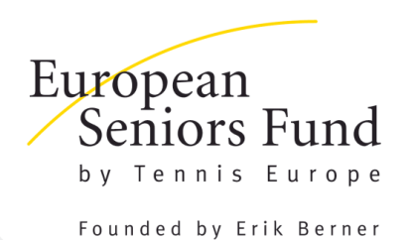
2022 GRANT APPLICATION FORM
PLEASE RETURN THIS FORM TO NADJA KORAN (nadjak@tenniseurope.org)
BEFORE 31st DECEMBER 2021.
PLEASE NOTE:
- LATE APPLICATIONS WILL NOT BE CONSIDERED
- ALL APPLICATIONS MUST BE SUBMITTED WITH THE SUPPORTING FINANCIAL DOCUMENTS REQUIRED

GENERAL INFORMATION:
This grant has been created to provide financial assistance to new senior tournaments in Tennis Europe C-Member nations in order to support and develop European tournaments on the ITF Senior Tour.
APPLICANT DETAILS:
Club Name:
Contact Person:
Address:
(Street Name and No.)
Postal Code:
City and Country:
Telephone/Mobile:
E-mail:
CLUB DETAILS:
Address: (If different)
Number of Courts:
Indoor/Outdoor:
Size of Club:
(Number of members)
Club Facilities: Restaurant:
Locker Rooms:
Other:
TOURNAMENT INFORMATION:
Tournament Name:
Tournament Director:
Date:
Age Categories offered:
TOURNAMENT BUDGET:
- PLEASE ESTIMATE THE TOTAL INCOME AND EXPENDITURE
2) INCLUDE A DETAILED COPY OF YOUR TOURNAMENT BUDGET
NATIONAL ASSOCIATION INFORMATION:
(ALL APPLICATIONS MUST BE SUBMITTED WITH THE SUPPORT OF THE NATIONAL ASSOCIATION)
National Association:
Contact Person:
Position in Association:
Telephone:
Email:
Signature:
Date:
Stamp of National Association:
APPLICANT SIGNATURE:
Name:
Position in Club:
Signature:
Date:

