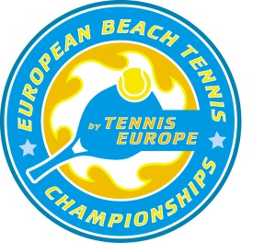

2014

EUROPEAN BEACH TENNIS CHAMPIONSHIPS
Brighton, UNITED KINGDOM

Nomination Form

National (Beach Tennis) Federation:

Responsible Person:

Mobile phone number:

Email address:

1. Mobile number captain/player:

2. Mobile number player:

Remember the ITF Beach Tennis Tour Rules and Regulations for the elegibility of players to represent a country.

Men’s Doubles

 | First Name | Surname | Date of Birth (dd/mm/yy) | Email Address
1
2
3
4
 | PLAYER 5 & 6 - only UK (host country)
5
6

Women’s Doubles
 | First Name | Surname | Date of Birth (dd/mm/yy) | Email Address
1
2
3
4
 | PLAYER 5 & 6 - only UK (host country)
5
6

Mixed Doubles
 | First Name | Surname
1
2
3
4

Captain
 | First Name | Surname | Email Address

Travel Details
Arrival of players and captain Date, time: | Departure Date, time:

We hereby confirm the eligibility of the above nominated players in accordance with the ITF Beach Tennis Tour Rules & Regulations. Furthermore, we confirm that the above nominated players will comply with the European Beach Tennis Championships conditions and requirements, which are outlined in the 2014 Circulars 1 and 2.

Name:

Signature:

National Association Stamp and Date:

To be returned by TUESDAY 1th JULY 2014
to Tennis Europe, Nadja Koran, nadjak@tenniseurope.org, Fax +41 61 331 7253

