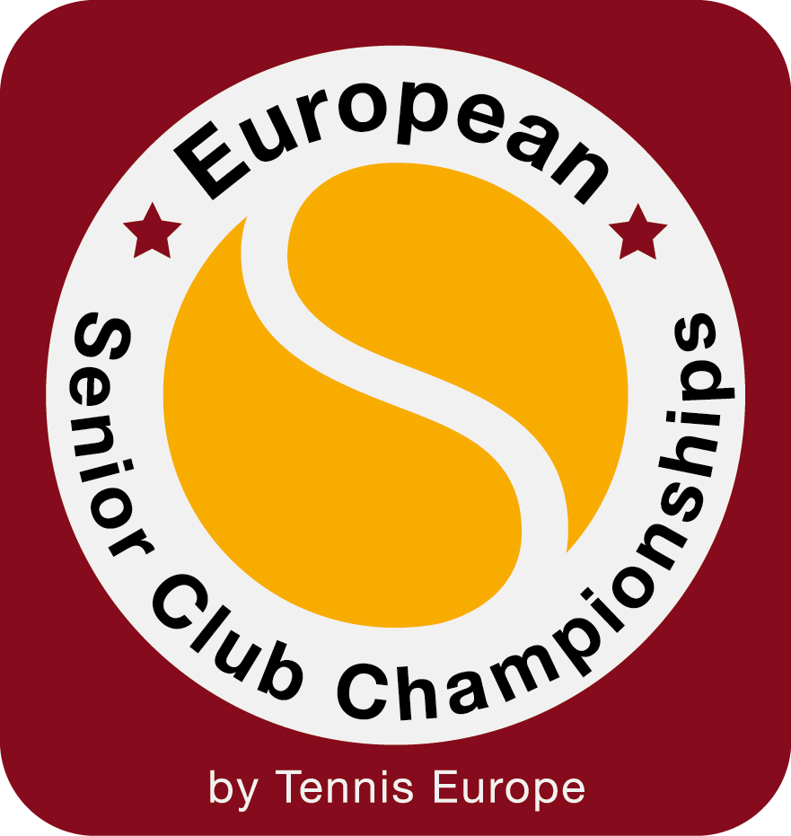
2016 EUROPEAN SENIOR CLUB CHAMPIONSHIPS
LA MANGA CLUB - SPAIN
19 - 24 September Men&Women 35, 40, 45, 50, 55, 60, 65, 70, 75
27 September -2 October Men&Women 35, 40, 45, 50, 55, 60, 65, 70, 75

ENTRY/Hotel reservation FORM

Please complete this form and return to the following fax number/email address by 31 JULY 2016:
La Manga Club: Fax: +34 968 33 1277 or Email: reservas@lamangaclub.com

AGE CATEGORY:

CLUB:

PERSONAL DETAILS (Essential details for booking)
Name: Surname: Accompanied by: __
Passport number:
Address: ____________
City: Postcode: Country: __________
Telephone: Mobile Phone: __________
Fax: E -mail: ____________
Credit Card Number: Expiry date: CVV: __

BOOKING DETAILS
Arrival date: _______________ Departure date: _____ No. of nights: ____________ No. of people:
Room types: Hotel La Manga Club Príncipe Felipe *****
No. of single rooms: ________________________ No. of double rooms: _________________________________
Las Lomas Village ****
No. of Panoramic rooms (double rooms): _________ No. of Apartments (3 double rooms with 3 bathrooms):

FLIGHT DETAILS
Arrival date: Departure date:
Airport: Airport: __________________
Time: Time:
Flight No. Flight No:

Credit card authorisation
In order to guarantee your reservation, full payment will be charged to your credit card between 30 and 20 days before arrival. Please complete your credit card details and sign where indicated.

Cancellations:
Please note that all cancellations must be made in writing. Where notification of cancellation is received with less than 20 days prior to the arrival, 50% of the total amount will be refunded. For cancellations less than 7 days prior to arrival, the full payment is not refundable.

Name: ___________________________Signature: ____________________________________ Date:

Participants staying at Hotel La Manga Club Príncipe Felipe or Las Lomas Village will enjoy the following benefits:
● Free access to the indoor pool, saunas, steam room and fitness centre at Spa La Manga Club ● Spa treatments 20% discount ● Lunch at Tie Break 10% discount ● Dinner at participating restaurants (a la carte) 20% discount ● Tennis Pro Shop 10% discount for players and partners ● Round of golf € 60

